2022 CCAP Priorities
Sample Social Media Posts for Counties

Below you will find sample social media posts categorized by each of the CCAP 2022 priority topics. Social media can be another way to communicate information to county residents, peers and legislators. Consider the following points when planning your county social media posts:

- Each social media platform has a different way for county residents, peers and legislators to engage. If your county utilizes multiple platforms, mix and match posts with images.
- Plan when to post, perhaps one every day for a week, one every Tuesday for five weeks.
- These posts can be used for general education about what counties do.
- Tell your county story! Include examples of relevant impacts to their programs and those they serve, within each of the following priorities as appropriate.
GENERAL
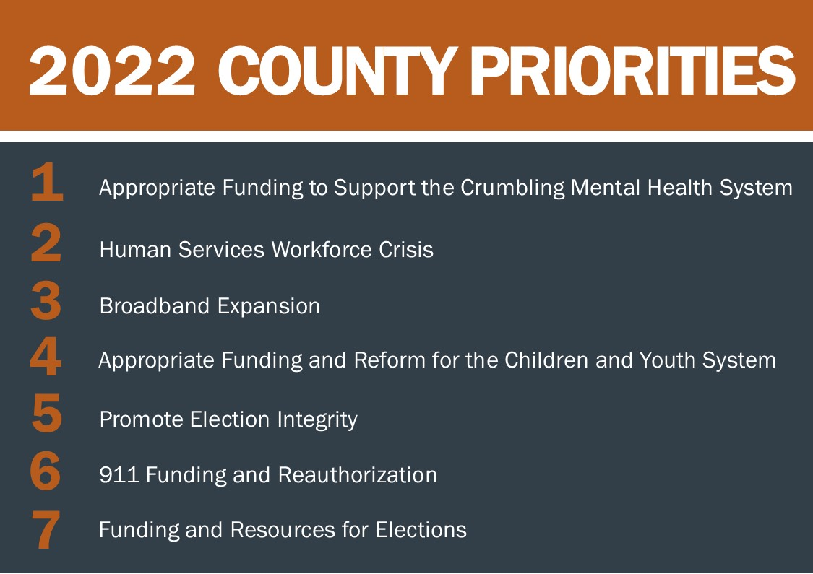

Post 1 (Facebook/Twitter/LinkedIn/Instagram)—Optional addition of graphic
The 2022 county priorities demonstrate the wide range of services counties provide on behalf of the commonwealth, and the need for strong state-county collaboration to better meet the needs of all Pennsylvanians.

Post 2 (Facebook/Twitter/LinkedIn/Instagram)—Optional addition of graphic
PA Counties have chosen seven legislative priorities for 2022! Check out www.pacounties.org
for more information on each of the priorities.
Post 3 (Facebook/LinkedIn/Instagram)—Optional addition of graphic
_______ County is pleased to announce the 2022 county priorities determined by counties across the commonwealth, including mental health funding, the human services workforce crisis, children and youth system reform, election integrity and funding and 911 funding and reauthorization.

INCREASED FUNDING FOR MENTAL HEALTH SERVICES
Post 1 (Facebook/Twitter/LinkedIn/Instagram)—Optional addition of personalization
Counties play a crucial role in the well-being of our constituents. That’s why we support a $28 million investment to rebuild and strengthen community crisis services, residential mental health programs and other locally provided care that will stabilize mental health services.

Post 2 (Facebook/LinkedIn/Instagram)—Requires personalization
Did you know that _____ County offers ____________? This program helps ____________. Adequate and sustainable funding for community mental health base is critical to keeping this program running and helping those who need it most.

HUMAN SERVICES WORKFORCE CRISIS
Post 1 (Facebook/Twitter/LinkedIn/Instagram)—Optional addition of personalization
Counties deliver crucial human services that protect our most vulnerable citizens. To combat the workforce crisis, we must work with the General Assembly to develop programs and partnerships to streamline human services recruitment efforts and create county employment pipelines.

Post 2 (Facebook/LinkedIn/Instagram)—Requires personalization
Did you know that _____ County offers ____________? This program helps ____________. Adequate and sustainable state and federal funding for county human services is critical to keeping this program running and helping those who need it most.

BROADBAND EXPANSION
Post 1 (Facebook /LinkedIn/Instagram)—Optional addition of personalization
With the promise of billions of dollars in federal investment under the Infrastructure Investment and Jobs Act, alongside the development of the statewide Pennsylvania Broadband Development Authority, counties are committed to working with federal, state, local and private stakeholders to develop strategies for successful broadband expansion that maximizes resources and minimizes overbuild.

Post 2 (Facebook/Twitter/LinkedIn/Instagram)—Requires personalization
Broadband expansion in PA is a crucial effort in 2022. _____ County is committed to partnering with higher education/research entities to leverage data, develop informational resources and build on technological innovations that aid in broadband infrastructure deployment.

APPROPRIATE FUNDING AND REFORM FOR THE CHILDREN AND YOUTH SYSTEM
Post 1 (Facebook /LinkedIn/Instagram)—Optional addition of personalization
Counties have the critical responsibility of assuring child welfare in the commonwealth through investigating allegations of child abuse and providing other services to the children and families in their communities. To effectively address the growing number of caseloads throughout the commonwealth and staffing shortages facing many human services agencies, counties require adequate funding from the state to enable hiring necessary caseworkers to address increasing caseloads.

Post 2 (Facebook/Twitter/LinkedIn/Instagram)—Requires personalization
____ County provides essential human services that protect some of the state’s most vulnerable residents, specifically children. To better serve these children and their families, investments must be made in county-based programs and services to address current staff shortages.

PROMOTE ELECTION INTEGRITY
Post 1 (Facebook /Twitter/LinkedIn/Instagram)—Optional addition of personalization
Since the enactment of Act 77 of 2019, it has become clear that additional adjustments to the Election Code are critical. To promote election integrity, we must clarify elements of Act 77 recommended by counties, including drop boxes, permanent voter lists and ballot signatures.

Post 2 (Facebook /LinkedIn/Instagram)—Requires personalization
To promote election integrity, _____ County supports extending the pre-canvassing period for mail-in and absentee ballots to allow ample time for counties to prepare ballots for tabulation so that accurate results can be provided as soon as possible. Read more at www.pacounties.org.

911 FUNDING AND REAUTHORIZATION
Post 1 (Facebook /LinkedIn/Instagram)—Optional addition of personalization
Counties provide one of the key functions in public safety—the operation of the 911 call-taking and dispatch system. But as technologies and the way people access 911 continue to evolve, funding and regulations need to account for upgrades to the system to ensure that standard of service is maintained. That is why it’s crucial to begin the development of funding formula that supports current county needs. Read more at www.pacounties.org.

Post 2 (Facebook/Twitter/LinkedIn/Instagram)—Optional personalization
To maintain the efficient operation of the 911 call-taking and dispatch systems, we support re-assessing the current funding stream that out of line with current realities. Now is the time for reexamining the 911 system so we can ensure a sustainable future.

ELECTION FUNDING AND RESOURCES
Post 1 (Facebook /LinkedIn/Instagram)—Optional addition of personalization
The implementation of mail-in ballots for all Pennsylvanians was a significant change to election administration, causing a significant increase to county budgets for elections-related costs in 2020 and 2021. That’s why it’s crucial that appropriate financial resources are allocated from the state to counties to support any new changes in election procedures, requirements, or equipment.

Post 2 (Facebook/Twitter/LinkedIn/Instagram)—Optional personalization
Changes to election administration have resulted in significant cost increases for counties. The state and counties must work together as new election policies are developed to assure resource needs are provided as counties perform the critical task of administering elections.

